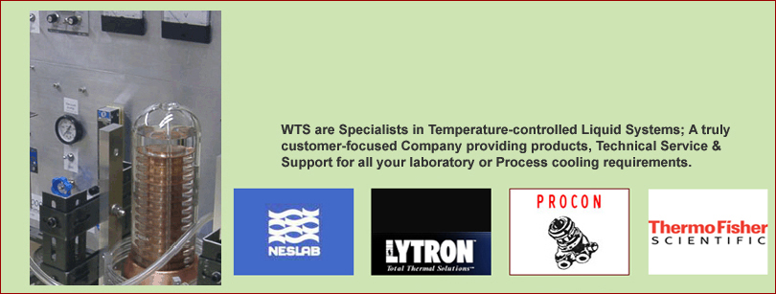



***This website is currently being upgraded.***

***WTS workshops are temporarily closed to new business.***

***WTS continue to offer technical sales of OEM & performance-matched spare parts & new units during this unforeseen period.***

***Workshop services will re-open as soon as possible. Thank you for your patience.***

